# Machine Learning

Bojan Božić & Bujar Raufi

School of Computer Science

TU Dublin, Grangegorman

bojan.bozic@tudublin.ie; bujar.raufi@tudublin.ie

Lecture 1: Introduction

Bojan Božić & Bujar Raufi

School of Computer Science

TU Dublin, Grangegorman

bojan.bozic@tudublin.ie; bujar.raufi@tudublin.ie

**Slides adapted from Sarah Jane Delany and book slides from: Fundamentals of Machine Learning for Predictive Data Analytics. Kelleher, Mac Namee and D’Arcy**

## Week 1 - Intro

### Overview

* Administrivia
* Module Outline
* Machine Learning Today - the good, the bad and the ugly
* Machine Learning Introduction
* What is (supervised) ML?
* Supervised v Unsupervised Learning
* Representing Data as Features

### Lecture and Lab:

* Thursday: 6pm to 10pm
* Weeks 1, 7 and 13 will be in-person (but streamed), the rest will be online
* No lecture on week 13 (07.05.2026)!
* All notes, lecture recordings, tutorials, lab work, and assignments will be available on Brightspace.
* For all module queries please contact: [bojan.bozic@tudublin.ie](mailto:bojan.bozic@tudublin.ie)

#### Book

* *Fundamentals of Machine Learning for Predictive Data Analytics*: John D. Kelleher, Brian Mac Namee, Aoife D'Arcy



#### ML with Python

* Tutorials and lab work require a laptop with Jupyter and scikit-learnn
* Require >> Scikit-learn >> <https://scikit-learn.org/stable/>



#### Assessment

* Assessment is based on CA + final exam:

|  |  |
| --- | --- |
| **Percentage** | **Activity** |
| 30% | Assignment - due in week 13 |
| 20% | Lab Test - scheduled for week 9 |
| 50% | End of Semester Exam |

### Machine Learning - Overview

* Supervised Learning
  + Classification: KNNs, Decision Trees, Naive Bayes
    - Neural Networks
    - Linear regression, Logistic Regression
  + Dimensionality Reduction
    - Feature Selection, PCA
  + The ML Process
    - Data Preprocessing, Missing Values, Scaling
    - Model Selection, Hyperparameters
  + Evaluation
  + Working with Text
  + Unsupervised Learning

#### Relevance of ML

* Explosion in rich, complex data to analyse - online and offline.
* •Significant recent progress in algorithms and theory.
* •Computational power is now available.
* •Industry demand - Data scientists, Data engineers…
* •New applications in many disciplines - medicine, engineering, humanities…
* Instagram >>
  + **2.4 billion users** end of 2024
  + Average Daily Usage of Instagram is **33 Minutes**
* Gmail
  + **more than 1.8 billion** users worldwide.
  + Around 22.22% of the global population uses Gmail.
  + **121 billion** emails daily (as of 2022 data)

#### How ML fits in this program

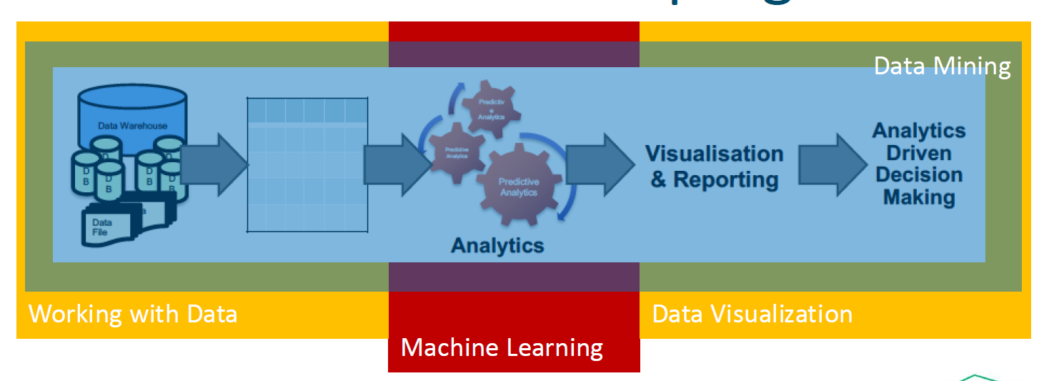

#### ML Today – Advances in AI

* Images - Dall-E: generating realistic images from a description in natural language <https://openai.com/dall-e-2/>



ChatGPT: A chatbot built on large language models that interacts in a conversational way <https://openai.com/blog/chatgpt/>

#### Reactions



<https://www.independent.ie/irish-news/politics/two-government-departments-confirm-use-of-chat-gpt/a1788591640.html>



<https://www.japantimes.co.jp/news/2023/01/24/asia-pacific/australian-colleges-chatgpt-disabled-students/>



<https://www.nytimes.com/2023/02/03/technology/chatgpt-openai-artificial-intelligence.html>



<https://www.thetimes.co.uk/article/irish-universities-in-race-against-time-with-chatgpt-to-avoid-widespread-cheating-scandals-kbpmtqqw9>

#### Education

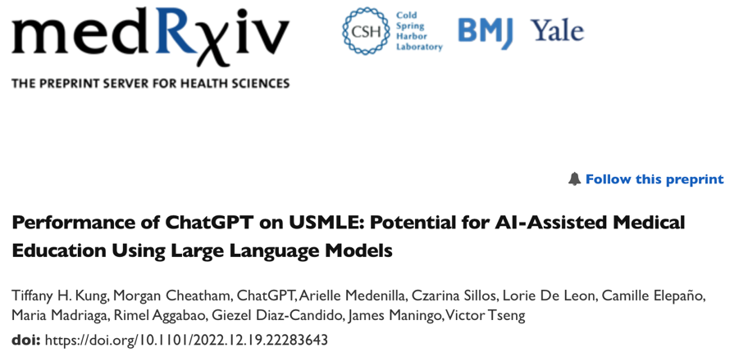

<https://www.medrxiv.org/content/10.1101/2022.12.19.22283643v2.full>



<https://www.cam.ac.uk/stories/ChatGPT-and-education>



<https://mackinstitute.wharton.upenn.edu/wp-content/uploads/2023/01/Christian-Terwiesch-Chat-GTP.pdf>

#### GPTZero to detect AI



<https://www.zerogpt.com/?gclid=CjwKCAiAkp6tBhB5EiwANTCx1AmcBLk3uO8ijqusyd1ngey8R2HZxG1WAwYgXoUuWFGDZ5xK7nVQlhoCad8QAvD_Bw>

#### But…

* ChatGPT can put together answers to questions but doesn’t “know” anything
* •No comprehensive understanding of the physical and social world, no ability to reason about relationships between concepts and entities
* •chatgpt failures guthub repo --- Examples of failures <https://github.com/giuven95/chatgpt-failures>

A year ago… 

This year…



#### DeepSeek

* Nvidia 2022 export ban
* •DS built at a fraction of the cost of industry-leading models like OpenAI - because it uses fewer advanced chips.
* •It is reportedly as powerful as OpenAI's o1 model - released at the end of last year - in tasks including mathematics and coding.
* •Like o1, R1 is a "reasoning" model. These models produce responses incrementally, simulating a process similar to how humans reason through problems or ideas. It uses less memory than its rivals, ultimately reducing the cost to perform tasks
* Source: <https://www.bbc.com/news/articles/c5yv5976z9po>



#### Next

* Applications will get more specific.
* •Regulation
* •EU AI Act
  + <https://artificialintelligenceact.eu/>

#### AI Systems are still brittle…



<https://www.theverge.com/tldr/2020/11/3/21547392/ai-camera-operator-football-bald-head-soccer-mistakes>

<https://medium.com/thoughts-and-reflections/racial-bias-and-gender-bias-examples-in-ai-systems-7211e4c166a1>



<https://www.theguardian.com/technology/2022/dec/22/tesla-crash-full-self-driving-mode-san-francisco>

### Expert Systems (Rule-Based Systems)

1. Rule:

**If**

– Income > Expenditure &

– Collateral > Loan

**Then**

– Risk = Low

Knowledge engineering



#### Learning from historical data



Predict decision for new instance

* Table of historical data
* Each row
  + description of instance
  + decision (Yes/No)

#### Learn What?

* + A.Learn expert decision-makingWhat if the expert gets it wrong sometimes?
  + B.Learn from outcomesOutperform experts



### Supervised learning

#### Supervised ML (Predictive Analytics)

* **Training Step:**
  + Learning a model from a set of historical data instances



#### Supervised ML (Predictive Analytics)

* **Prediction Step:**
  + Using the model to make predictions



#### Classification Task

* Example: Credit scoring
  + A training set with 10 examples (customers)
  + example has one of two class labels = {High-risk, Low-risk}

#### Classification task

* Manually classify customers into two categories (low-risk and high-risk) based on savings and income data.
* **If** 
  + income > ⍺ & savings > β
* **Then** 
  + Risk - low



#### Classification Task

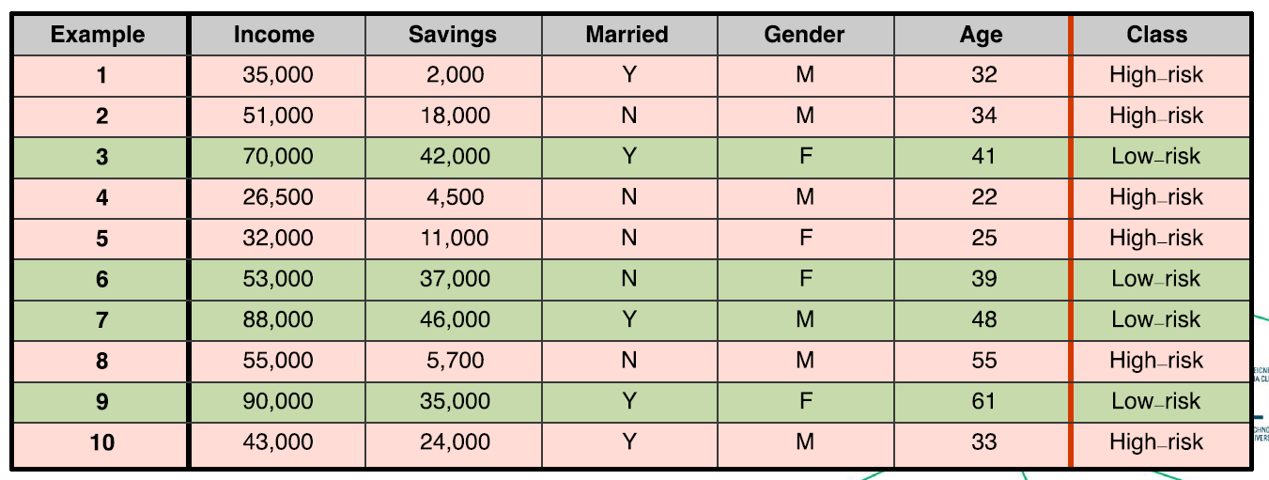

**Q. To which class does this new customer belong?**



**Q. Can we train an algorithm to learn to automatically classify new customers as either low-risk or high-risk?**

#### Supervised Learning

* Supervised Machine Learning algorithms automate the process of learning a model that captures the relationship between the **descriptive features** and the **target feature** in a **training dataset.**



* ML algorithms search through all possible patterns that exist between a set of descriptive features and a target feature to find the best model that is **consistent** with the training data (i.e. agrees with all the training instances).
* •Useful predictive models must be able to **generalise** well, i.e. make predictions for queries that are not present in the training data.

#### What can go wrong?

* **Underfitting** occurs when the prediction model is too simplistic to represent the underlying relationship between the descriptive and target features.
* •**Overfitting** occurs when the model is so complex that it fits the data too closely and becomes sensitive to noise (e.g. mislabelled feature values).



### Supervised Learning Algorithms

* Typically, training data does not have enough information to choose a single best model, so additional assumptions are needed to drive the model selection, known as the **inductive bias.**
* **Restrictive bias** constrains the set of models that will be considered (e.g. linear regression considers models that produce predictions based on a linear combination of descriptive features)
* **Preference bias** guides the algorithm to prefer certain models over others (e.g., the decision tree prefers shallower trees)
* Different algorithms have a different inductive bias,
* It is important to identify the machine algorithm that will fit the predictive task most appropriately.

#### Supervised ML (aka Predictive Analytics)



#### Supervised ML (aka Predictive Analytics)



### Supervised vs. Unsupervised Learning

* **Supervised Learning:**
  + An algorithm that learns a function from examples of its inputs and outputs. It uses manually labelled example data (i.e. a training set ) to predict the correct answer for new unseen query inputs
  + .e.**g. Classification, regression algorithms**
* **Unsupervised Learning:**
  + An algorithm that finds structure in data where no manually labelled examples are available as inputs - i.e. there is no training set. These algorithms are more focused on data exploration and knowledge discovery.
  + e.g. **Clustering, topic modelling algorithms**

#### Supervised Learning

* **Classification:**
  + Examples are represented by a set of features, which help decide the target class to which a new query input belongs (i.e. the output is a class label or target feature).
* **Regression:**
  + Examples are characterized by a set of features which help decide the value of a continuous output variable (i.e. the output is a number).



#### Classification Tasks

* **Binary classification:** Assign a new query input to one of two possible target class labels.



* **Multiclass classification:** Assign a new query input to one of M > 2 different target class labels.



#### Representing Data

* Commonly, we use a tabular structure to represent a dataset, often referred to as the **analytics base table (ABT)**.
* •Each row represents a different example and comprises a set of **descriptive features**.
* •For prediction, each row also has a **target class label** or **target feature** for classification and regression, respectively - i.e. the “correct answer".



#### Representing Data

* The descriptive features used to represent examples can be distinguished by the type and number of values they can take.
* **Binary:** Takes only two values - a boolean True/False decisione.g. married={True, False}, test_result={Pass, Fail}
* **Categorical (Nominal):** A feature that takes values from a finite set of values, with no intrinsic ordering to the valuese.g. blood_group={A,B,AB,O}, nationality={French, Irish, Italian}
* **Ordinal:** A categorical variable with a clear ordering of the variables.e.g. grade={A, B, C, D, E, F}, dosage={Low, Medium, High}
* **Interval:** Values that allow ordering and subtraction but do not allow other arithmetic operationse.g date, time
* **Continuous:** Numeric measurements, with or without a fixed range for the values.e.g. temperature, price, age, weight, height, latitude, longitude etc.

#### Typical Classification Task

* The training set with N=10 examples (customers). Each is described by D=5 features: 3 continuous, 2 categorical
* Each example has one of two class labels = {High-risk, Low-risk}



* Q. To which class does this new customer belong?



### Algorithms

* Many different learning algorithms exist for prediction (e.g. k -nearest neighbour, decision tree, neural network, support vector machine).
* •Due to processing, memory, and storage constraints, problem dimensions will often determine which algorithm will be practically applicable.
* 1.Number of input examples N.
  + Sometimes millions of input examples.
* 2.Number of features (dimensions) D representing each input example.
  + Often 10-1000, but sometimes far higher.
* 3.For classification, the number of target classes M.
  + Often small (binary), but sometimes far higher.

### Machine Learning - Overview

* Supervised Learning
* •Classification: KNNs, Decision Trees, Naive Bayes
  + Neural Networks
  + Linear regression, Logistic Regression
* •Dimensionality Reduction
  + Feature Selection, PCA
* •The ML Process
  + Data Preprocessing, Missing Values, Scaling
  + Model Selection, Hyperparameters
* •Evaluation
* •Working with Text
* •Unsupervised Learning

### Questions ?

### Lab solution - LAB1_Preprocessing_Sols _updated.ipynb

‘’’ py

## Lab Exercise Week #1: Mastering Data Preprocessing in Machine Learning

### Objective:

The goal of this lab exercise is to delve into advanced data preprocessing techniques used in machine learning. Preprocessing is an important step in Machine Learning, otherwise you end-up with "garbage-in garbage-out" paradigm, meaning you feed the machine learning algorithm with bad data, you can expect bad performance. You will work with real-world datasets, handling missing data, encoding categorical variables, scaling features, and more.

### Dataset:

For this exercise, we will use the "<a href="https://archive.ics.uci.edu/ml/machine-learning-databases/adult/adult.data">Adult Income</a>" dataset from the UCI Machine Learning Repository. This dataset contains various features related to individuals and aims to predict whether a person earns more than $50,000 per year.

### Tasks:

#### 1). Data Loading and Initial Exploration:

<ul>

<li>Load the "Adult Income" dataset. Loading can be done by accessing it locally, after you have download it, or direct access via URL provided above.</li>

<li>Explore the dataset to understand its structure and features. Check the feature structure from the <a href="https://archive.ics.uci.edu/dataset/2/adult">UCI Repository</a>.</li>

<li>Identify the target variable and its distribution.</li>

</ul>

# Import necessary libraries

import numpy as np

import pandas as pd

from imblearn.over_sampling import RandomOverSampler

from sklearn.model_selection import train_test_split

from sklearn.impute import SimpleImputer

from sklearn.preprocessing import StandardScaler, OneHotEncoder

from sklearn.compose import ColumnTransformer

from sklearn.pipeline import Pipeline

from sklearn.ensemble import RandomForestClassifier

from sklearn.metrics import accuracy_score, classification_report

# Task 1: Data Loading and Initial Exploration

url = "https://archive.ics.uci.edu/ml/machine-learning-databases/adult/adult.data"

column_names = ['age', 'workclass', 'fnlwgt', 'education', 'education-num', 'marital-status', 'occupation', 'relationship',

'race', 'sex', 'capital-gain', 'capital-loss', 'hours-per-week', 'native-country', 'income']

data = pd.read_csv(url, names=column_names, sep=',\s', na_values=["?"])

# Explore the dataset

print("Dataset Info:\n", data.info())

print("\nTarget Variable Distribution:\n", data['income'].value_counts())

data

#### 2). Handling Missing Data:

<ul>

<li>Identify missing values in the dataset.</li>

<li>Implement a strategy to handle missing data (e.g., imputation or removal). Impute missing values with the median for numerical columns and the most frequent value for categorical columns.</li>

<li>Justify the chosen strategy.</li>

</ul>

# Task 2: Handling Missing Data

# Impute missing values with the median for numerical columns and the most frequent value for categorical columns

numerical_features = data.select_dtypes(include=['int64', 'float64']).columns

categorical_features = data.select_dtypes(include=['object']).columns

# exclude the income column as it will be the output column -it will be the target variable

categorical_features = categorical_features[~categorical_features.isin(['income'])] # exclude the income column as it will be the output column

numerical_transformer = SimpleImputer(strategy='median')

categorical_transformer = SimpleImputer(strategy='most_frequent')

preprocessor = ColumnTransformer(

transformers=[

('num', numerical_transformer, numerical_features),

('cat', categorical_transformer, categorical_features)

])

numerical_features

categorical_features

#### 3). Encoding Categorical Variables:

<ul>

<li>Identify categorical variables in the dataset.</li>

<li>Apply appropriate encoding techniques (e.g., one-hot encoding or label encoding). Use one-hot encoding for categorical variables.</li>

<li>Discuss the impact of encoding choices on model performance.</li>

</ul>

# Task 3: Encoding Categorical Variables

# Use one-hot encoding for categorical variables

preprocessor = ColumnTransformer(

transformers=[

('num', numerical_transformer, numerical_features),

# find cat no in the data ignore it...apply onehotencoding...

# convert categorical to binary numercial features

('cat', OneHotEncoder(handle_unknown='ignore'), categorical_features)

])

#### 4). Feature Scaling:

<ul>

<li>Identify features that require scaling.</li>

<li>Apply feature scaling using techniques such as Min-Max scaling or Standardization.</li>

<li>Discuss the importance of feature scaling in different machine learning algorithms.</li>

</ul>

# Task 4: Feature Scaling

# Apply Standardization to numerical features

preprocessor = ColumnTransformer(

transformers=[

# make sure all numbers are between 0 and 1

# i.e. age - between 10 and 18 and ayment = between 10K and 15K .. => payment dominates the model as bigger numbers

# so standardise so each feature contributes equally

# preserves shape + keeps negative values....

# Need to scale for >>> LinReg / LogReg / SVM / k-NN / PCA / NN

# do not need to scale for >> DT / RF / GradBoost (XGBoost, LightGBN)

#### NEVER FIT SCALAR on TEST DATA?? >>> fit on trainnig set..... transform train and tes using same scalar...otherwise data leakage

# DStandardScalar + MinMaxScalar + RobustScalar

('num', StandardScaler(), numerical_features),

('cat', OneHotEncoder(handle_unknown='ignore'), categorical_features)

])

#### 5). Feature Engineering:

<ul>

<li>Create new meaningful features based on existing ones.</li>

<li>Discuss how feature engineering can enhance model performance.</li>

</ul>

# Task 5: Feature Engineering

# Create a new feature "capital-diff" as the difference between capital-gain and capital-loss

data['capital-diff'] = data['capital-gain'] - data['capital-loss']

#### 6). Outlier Detection and Handling:

<ul>

<li>Identify potential outliers in numerical features.</li>

<li>Implement a strategy to handle outliers (e.g., removal or transformation).</li>

<li>Discuss the impact of outliers on model training.</li>

</ul>

# Task 6: Outlier Detection and Handling

# Identify and handle outliers using a suitable method (e.g., Z-score or IQR)

#### 7). Normalization and Transformation:

<ul>

<li>Apply normalization to achieve a normal distribution in numerical features.</li>

<li>Discuss the benefits of normalization in specific machine learning algorithms.</li>

</ul>

# Task 7: Normalization and Transformation (You can use standard scalar, minmax scalar or robust scalar)

# Apply normalization to achieve a normal distribution in numerical features

#### 8). Data Splitting:

<ul>

<li>Split the dataset into training and testing sets.</li>

<li>Justify the chosen ratio and the importance of a proper train-test split.</li>

</ul>

# Task 8: Data Splitting

X = data.drop('income',axis=1)

y = data['income']

print("input columns", X.columns)

print("output columns", y.name)

# split data as 80% for training and 20% for testing

# randome ensure reproduces the same each time

X_train, X_test, y_train, y_test = train_test_split(X, y, test_size=0.2, random_state=42)

print("shapes of training and testing")

print('X_train shape:', X_train.shape)

# output for yoru model, will be included in the training

print('y_train shape:', y_train.shape)

# test data for features

print('X_test shape:', X_test.shape)

# is the output in the mdoel used to check the accuracy fo the classifier

print('y_test shape:', y_test.shape)

X_train.columns

y

#### 9). Handling Imbalanced Data:

<ul>

<li>Identify if the target variable has an imbalanced distribution.</li>

<li>Implement techniques to handle imbalanced data (e.g., oversampling or undersampling).</li>

<li>Discuss the challenges posed by imbalanced datasets.</li>

</ul>

#Identify if the target variable has an imbalanced distribution.

# check the ytrain distribution - cna see what values you have fo ech class...has two classes

# cna see theres an imbalance

print("Class distribution before oversampling:")

print( y_train.value_counts())

# add mor samples for class that has lower number of samples

oversampler = RandomOverSampler(random_state=42)

# Apply the oversampling technique to the training set

# once applied datag will bebalanced for the training

X_train_resampled, y_train_resampled = oversampler.fit_resample(X_train, y_train)

print("Class distribution after oversampling:")

# can see no imbalance now...

print( y_train_resampled.value_counts())

#### 10). Pipeline Implementation:

<ul>

<li>Construct a preprocessing pipeline that includes all the steps above.</li>

<li>Discuss the advantages of using a pipeline in the context of reproducibility and efficiency.</li>

</ul>

# Task 10: Pipeline Implementation

# Construct a preprocessing pipeline with a classifier

pipeline = Pipeline(steps=[

('preprocessor', preprocessor),

# choose RF classifier

('classifier', RandomForestClassifier(random_state=42))

])

# Fit the pipeline on training data

# train the pipeline -- means all the traing data will ebpassed thru pre-processing steps first then thru classifier...

pipeline.fit(X_train_resampled, y_train_resampled)

# Make predictions on test data

# thsi tests yuor model...

# y_pred is the var for the predicted values...

y_pred = pipeline.predict(X_test)

# Evaluate the model

print("Accuracy:", accuracy_score(y_test, y_pred))

print("Classification Report:\n", classification_report(y_test, y_pred))

‘’’

## Week 2 – Similarity-based Learning (kNN) -n K means clustering

**Module Outline**

### Lab - LAB2_kNN.ipynb

Lab link >> <https://scikit-learn.org/stable/auto_examples/neighbors/plot_classification.html#sphx-glr-auto-examples-neighbors-plot-classification-py>

## Week 3 – Decisions Trees

* Moving into information based territory
* Bery popular and very well known
* Bery intuitive and used in a lto of things aswell…

### Guess Who game

## Complete

* Week 1
  + Content into this doc from pdf/ppt – yes completed
  + Lab completed – yes completed
  + Lab video watched back – yes completed – up to 30 mins….
  + Content Video watched back and notes added to this doc – no . sart @ 30 mins
  + Notes done in copy book? – no